VW Bus Type IV Engine – Complete
Engine # GD002296 1976-1977
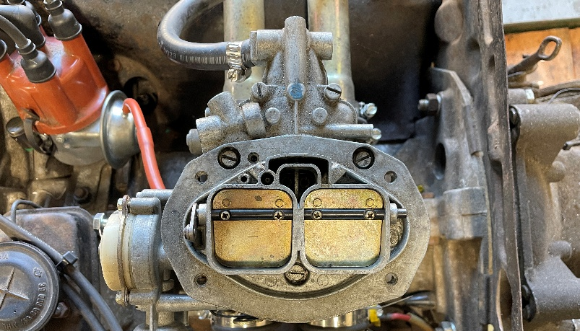
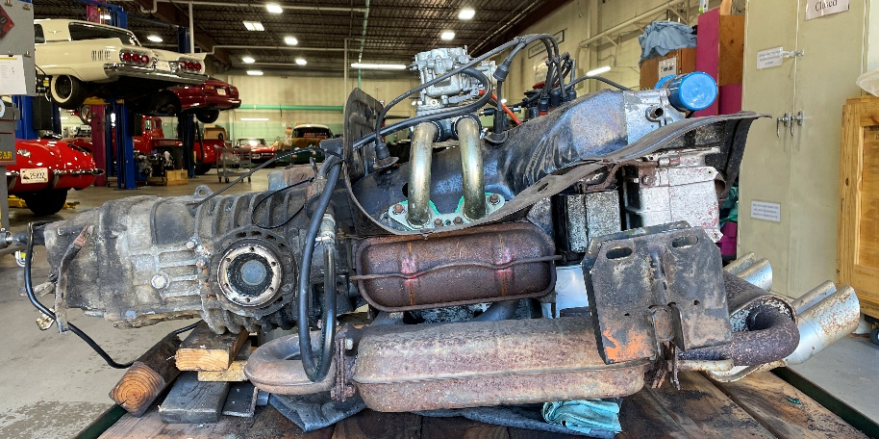
2.0 Litre – solid lifter
For videos of: engine running – oil pressure and compression
go to www.cardoneanddaughter.com/sales/engine

- Converted from fuel injection to carb:
Weber 32/36 DFEV progressive 2 barrel (does not include electric fuel pump)

Recent: oil & filter, spark plugs, points, intake gaskets, intake boots, rear main seal
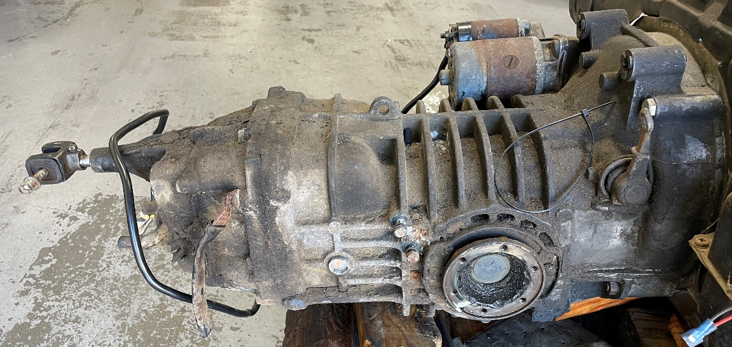

4-Speed Transaxle also available –
for video and transaxle shifting (mounted to running engine) go to www.cardoneanddaughter.com/sales/engine

Also available: new clutch kit: 228mm disc, pressure plate, throwout bearing

Cardone & Daughter Automotive, Inc.
4 Custom Drive Old Saybrook, CT 06475 PHONE: (860) 664-0727

